**TOPIC B: ASSIMILATION**

**1.Introduction to the Topic:** Assimilation describes the process by which a [minority](https://www.boundless.com/sociology/definition/minority/) integrates socially, culturally, and/or politically into a larger, [dominant](https://www.boundless.com/sociology/definition/dominant/) [culture](https://www.boundless.com/sociology/definition/culture/) and [society](https://www.boundless.com/sociology/definition/society/). The term assimilation is often used in reference to immigrants and [ethnic](https://www.boundless.com/sociology/definition/ethnic-group/)[groups](https://www.boundless.com/sociology/definition/group/) settling in a new land. Immigrants acquire new customs and attitudes through contact and communication with a new society, while they also introduce some of their own cultural traits to that society.

Assimilation usually involves a gradual change of varying degree. Full assimilation occurs when new members of a society become indistinguishable from native members.

Any group (such as a state, immigrant [population](https://www.boundless.com/sociology/definition/population/), or ethnicity) may choose to adopt a different culture for a variety of reasons such as political relevance or perceived advantage. However, a group may also be forced or feel compelled to do so as a result of imperialistic conquest, [immigration](https://www.boundless.com/sociology/definition/immigration/), or drastic changes in population.

**KEY TAKEAWAYS**

* Assimilation is the public absorption of issued shares.
* Shares that are well priced and have been marketed well should be assimilated and easily absorbed.
* If shares are not assimilated or easily absorbed by the public, that could indicate the shares were improperly priced or inadequately marketed.

## **2.Types of Assimilation**

The following are some examples of assimilation:

* **Color assimilation** - This is perhaps one of the easiest models that demonstrates assimilation. If you mix a small amount of the color red with a large amount of blue, the red is assimilated into the larger mix. Though the red is absorbed, it changes the hue of blue so that it becomes something different and shifts in the [spectrum](http://images.yourdictionary.com/color) of color.
* **Cultural assimilation** - Cultural assimilation happens when two cultures or groups of people influence one another. Cultural customs, traditions, and religious practices can all be assimilated between two or more cultures. Often times, these groups live near one another. Influence may be derived from trade, invasion, and/or intermarrying between the groups.
* **Religious assimilation** - A perfect example of religious assimilation is the assimilation of Pagan customs and ceremonies into Christianity. When Christianity became the predominate religion, they took Pagan holy days such as Yule and the Spring Equinox, or Ostara, and claimed them as Christmas and Easter. They adopted traditions such as the decorating of fir trees at Christmas and the use of symbols of fertility at Easter such as Easter eggs.

Another example of religious assimilation would be that of the Romans and Greeks. When Rome conquered Greece, they adopted their gods; Zeus, ruler of the gods, became Jupiter, Poseidon, god of the sea, became Neptune, Hades became Pluto, and the list goes on.

* **Linguistic assimilation** - This type of assimilation often occurs when two neighboring groups of people or territories influence one anothers' way of speaking.

For example, in the North East of America, there is a very distinctive, almost nasal, accent. Within that large group, there are smaller pockets of accents -- a Boston accent would be different from a Brooklyn accent, for instance -- however, both accents are easily identifiable as the larger whole of a "North-Eastern" accent. Linguistic assimilation also occurs in popular slang. Often, neighboring communities will have different slang words for the same things. If you move from one place to another, over time, you will quite often pick up on, and assimilate your own language with, the new slang or dialect.

* **Physiological assimilation** - Physiological assimilation refers to the conversion of ingested nutrients into energy that fuels the body as a greater whole. For example, a starch molecule will be broken down into smaller carbohydrates, some of which will be used for fuel and others which can be modified to become part of the cell structure of the organism.
* **Statistical assimilation -** Assimilation in a statistical capacity refers to the gathering data over time to in order obtain a clearer picture of that which is being studied. Data is assimilated and allows the person compiling the statistics a better understanding of how things work over all. A piece of data collected is assimilated into the model and becomes part of the mechanism by which all of the subsequent data is interpreted.

These examples of assimilation should give you a better idea of all of the different types of assimilation and how they occur.

**3.History**

Attempts to compel minority groups to [assimilate](https://www.merriam-webster.com/dictionary/assimilate) have occurred frequently in world history. The forced assimilation of [indigenous](https://www.merriam-webster.com/dictionary/indigenous) peoples was particularly common in the European [colonial](https://www.britannica.com/topic/Western-colonialism) empires of the 18th, 19th, and 20th centuries. In North and South America, Australia, Africa, and Asia, colonial policies toward indigenous peoples frequently compelled their religious conversion, the removal of children from their families, the division of [community property](https://www.britannica.com/topic/community-property) into salable, individually owned parcels of land, the undermining of local economies and gender roles by shifting responsibility for farming or other forms of production from women to men, and the elimination of access to indigenous foodstuffs. Forced assimilation is rarely successful, and it generally has enduring negative consequences for the recipient culture.

Voluntary assimilation, [albeit](https://www.merriam-webster.com/dictionary/albeit) usually effected under pressure from the dominant culture, has also been prevalent in the historical record. One such case dates to the [Spanish Inquisition](https://www.britannica.com/topic/Spanish-Inquisition) of the late 14th and 15th centuries, when many Muslims and Jews responded to religious persecution by voluntarily converting to [Roman Catholicism](https://www.britannica.com/topic/Roman-Catholicism). Known as [Moriscos](https://www.britannica.com/topic/Morisco) and [Marranos](https://www.britannica.com/topic/Marrano), respectively, they secretly continued to practice their original religions.

Another example of voluntary assimilation occurred during the 18th and 19th centuries, when millions of Europeans moved to the [United States](https://www.britannica.com/topic/Americanization). In this case, being able to “pass” as a member of the dominant Anglo-Protestant culture was an important hedge against violent nativist groups such as the [Know-Nothing Party](https://www.britannica.com/topic/Know-Nothing-party) (*see* [United States: The people](https://www.britannica.com/place/United-States/People#ref77996)). Although popular notions generally presume that complete assimilation occurred among immigrants of European descent, research in the late 20th and early 21st centuries advocated a more [nuanced](https://www.merriam-webster.com/dictionary/nuanced) and [pluralistic](https://www.britannica.com/topic/pluralism-politics) view of historical culture change among American [ethnic groups](https://www.britannica.com/topic/ethnic-group).

### Canada 1800s–1990s: Forced assimilation of Aboriginals

During the 19th and 20th centuries, and continuing until 1996, when the last residential school was closed, the Canadian government, aided by Christian Churches began a campaign to forcibly assimilate [Aboriginals](https://en.wikipedia.org/wiki/Indigenous_peoples_in_Canada). The government consolidated power over Aboriginal land through treaties and the use of force, eventually isolating indigenous people to reserves. Marriage practices and spiritual ceremonies were banned, and spiritual leaders were imprisoned. Additionally, the Canadian government instituted an extensive residential school system to assimilate children. Indigenous children were separated from their families and no longer permitted to express their culture at these new schools. They were not allowed to speak their language or practice their own traditions without receiving punishment, which was commonly in the form of violent or sexual abuse by the Christian church. The Truth and Reconciliation Commission of Canada concluded that this effort was violent enough to amount to [cultural genocide](https://en.wikipedia.org/wiki/Cultural_genocide). The schools actively worked to alienate children from their cultural roots. Students were prohibited from speaking their native languages, were regularly abused, and were arranged marriages by the government after their graduation. The explicit goal of the Canadian government, through the Catholic and Anglican churches, was to completely assimilate the Aboriginals into European culture and destroy all traces of their native history.

### Brazil

In January 2019, newly elected [Brazil](https://en.wikipedia.org/wiki/Brazil)'s president [Jair Bolsonaro](https://en.wikipedia.org/wiki/Jair_Bolsonaro) has stripped the indigenous affairs agency [FUNAI](https://en.wikipedia.org/wiki/Funda%C3%A7%C3%A3o_Nacional_do_%C3%8Dndio) of the responsibility to identify and demarcate [indigenous lands](https://en.wikipedia.org/wiki/Indigenous_territory_(Brazil)). He argued that those territories have very tiny isolated populations and proposed to integrate them into the larger Brazilian society.According to the [Survival International](https://en.wikipedia.org/wiki/Survival_International), "Taking responsibility for indigenous land demarcation away from FUNAI, the Indian affairs department, and giving it to the Agriculture Ministry is virtually a declaration of open warfare against [Brazil’s tribal peoples](https://en.wikipedia.org/wiki/Indigenous_peoples_in_Brazil)."

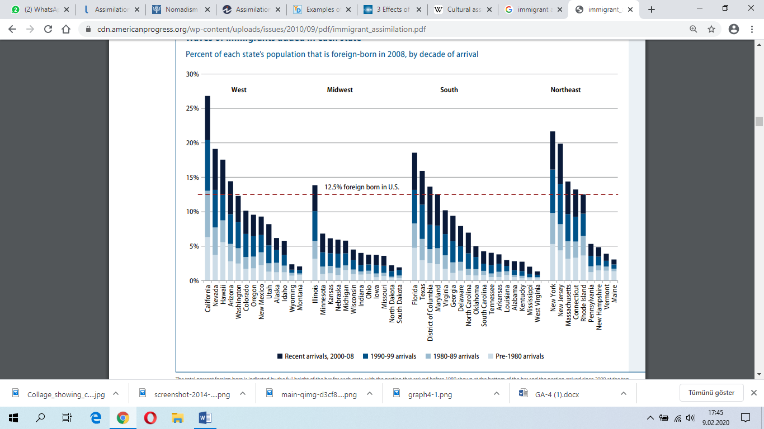

## **4.** **Effects of Immigration and Assimilation**

An important concern in immigration research involves the effects of immigration and assimilation on health, education, and social programs, particularly in areas of high immigration concentration. Much folk wisdom has viewed assimilation as a linear process of progressive improvement and adjustment to American society. The general assumption is guided by an implicit deficit model: to advance socially and economically in the United States, immigrants need to "become American" in order to overcome their deficits in the new language and culture. As they shed the old and acquire the new, they acquire skills for working positively and effectively—a process that may not be completed until the second or third generation after entry.

Today's immigration is overwhelmingly composed of newcomers from Asia and Latin America, areas with significantly different languages and cultures than those of previous European immigrants in the late 1800s and earlier decades of the 1900s. Concerns have been raised about the speed and degree to which these immigrants can assimilate—and hence about the social "costs" of these new immigrants—before they begin to produce net benefits to their new society. The traditional assumption is that immigrants have costs to U.S. society in the initial period after arrival, but that the costs decrease and the benefits to society increase as duration of residence increases. It is further assumed that the benefits to society also increase with greater assimilation to American culture. Recent research findings, however, especially in the areas of perinatal health, mental health, and education, raise significant questions about such assumptions. Indeed, some of the findings run precisely opposite to what might be expected from traditional notions and theories of assimilation.

This chapter captures the workshop discussions of the effects of immigration and assimilation on social policies and programs, health, and education.

### ****Social Policy and Welfare****[****1****](https://www.nap.edu/read/4942/chapter/5#p200065b78960029001)

Immigration researchers disagree about many major issues that are essential for revising social policy, including the criteria used to admit immigrants and the extent of social supports required to ensure their successful integration. More specific areas of disagreement include: whether recent arrivals are less skilled than earlier arrivals; whether the pace of socioeconomic assimilation has slowed in recent years and, if so, why; whether the net social and economic impacts of immigration are positive or negative; which social groups and communities are the net beneficiaries (or losers) from the influx of new immigrants; whether legal immigrants, illegal aliens, and refugees face dissimilar prospects for integration in the United States and, if so, why; and whether the criteria currently used to admit immigrants are optimal for achieving social, political, humanitarian, and economic objectives. All analysts agree that reliable answers to all of these questions are necessary for future policy initiatives concerned with employment, schooling, and income maintenance.

Despite the many areas of disagreement among immigration experts, there is widespread consensus on three issues: (1) the volume of immigration is likely to increase over the next decade, (2) the demographic and socioeconomic diversity of the flows has increased in recent decades, and (3) currently available data are ill-suited to address adequately many policy-relevant questions about how immigration contributes to contemporary patterns of stratification.

### Naturalization and Immigrant Assimilation

Other than marriage, citizenship is one of the most significant factors in assimilation. Thus, immigration debates focus not only on the number of immigrants that should be admitted into a country and the processes of incorporation but also on how citizenship should be extended and to whom. Proponents of immigration often argue that new residents will help to build and enrich American [democracy](https://www.boundless.com/sociology/definition/democracy/), while opponents counter that the [identity](https://www.boundless.com/sociology/definition/identity/) and legitimacy of the nation may be challenged and perhaps even threatened by immigrants. Questions of citizenship in relation to [illegal immigration](https://www.boundless.com/sociology/definition/illegal-immigration/) is a particularly controversial issue and a common source of political tension.

### New Immigrant Gateways and Immigrant Assimilation

The majority of immigrants have tended to settle in [traditional](https://www.boundless.com/sociology/definition/traditional/) gateway states such as Florida, New York, California, Illinois, Texas, and Massachusetts, where immigrants find large existing populations of foreign-born people. Recently, however, immigrants have increasingly been settling in areas outside these gateway states. [Sociologists](https://www.boundless.com/sociology/definition/sociologist/) Mary Waters and Tomas R. Jimenez have suggested that these geographical shifts may change the way researchers assess immigrant assimilation, as immigrants settling in new areas may encounter different experiences than immigrants settling in [more](https://www.boundless.com/sociology/definition/mores/) traditional gateways. Specifically, Waters and Jimenez identify three distinguishing characteristics in more recent, less traditional, immigration patterns: less established social [hierarchies](https://www.boundless.com/sociology/definition/hierarchy/), smaller immigrant population size, and different institutional arrangements.

### Segmented Assimilation

The [theory](https://www.boundless.com/sociology/definition/theory/) of segmented assimilation for second generation immigrants is highly researched in the sociological arena. Segmented assimilation, researched by Min Zhou and Alejandro Portes, focuses on the notion that people take different paths in how they adapt to life in the United States. This theory states that there are three main different paths of assimilation for second generation immigrants. Some immigrants assimilate smoothly into the white middle [class](https://www.boundless.com/sociology/definition/class/) of America, others experience downward assimilation, and others experience rapid economic success while preserving the values of their immigrant community.

This theory also includes the concept of modes of incorporation, which are the external factors within the host community that affect assimilation. These factors are created by the underlying policies of the government, the strength of [prejudice](https://www.boundless.com/sociology/definition/prejudice/) in the society, and the makeup of coethnic communities within the society. These modes of incorporation affect how a child will assimilate into U.S. society, and determine how vulnerable the child will be towards downward assimilation. Factors that enhance such vulnerability include racial [discrimination](https://www.boundless.com/sociology/definition/discrimination/), location, and changes in the [economy](https://www.boundless.com/sociology/definition/economy/) that have made it harder for [intergenerational mobility](https://www.boundless.com/sociology/definition/intergenerational-mobility/).

In addition, differing modes of incorporation make available certain [resources](https://www.boundless.com/sociology/definition/resource/) that second generation immigrants can use to overcome challenges to the process of assimilation. If the child belongs to a group that has been exempt from the prejudice experienced by most immigrants, such as European immigrants, they will experience a smoother process of assimilation. A second generation immigrant can also make use of established networks in the coethnic community. These networks provide these children with additional resources beyond those offered by the government, such as gateways into well-paying jobs in businesses established by the ethnic community. Children of middle-class immigrants have a greater likelihood of moving up the social ladder and joining American [mainstream](https://www.boundless.com/sociology/definition/mainstream/) society than children of lower class immigrants, as they have access to both the resources provided by their parents and to the educational opportunities afforded to the middle class in the U.S.

**5. Measuring immigrant assimilation**

The successful outcome of assimilation by immigrants and their children who arrived in America early in the 20th century is well recognized some 100 years later. But the course of immigrant assimilation for those who came over the past 20 years is not as widely known, especially in parts of the nation where newcomers have most recently arrived. Initially, the upswing in immigration sweeping the United States after 1970 was concentrated largely in California, New York, Texas, Florida, and Illinois, but now it has spread much more widely across the country.

Because assimilation takes time before its effects are visible, and because, until now, firm data has been lacking to track its progress, there is confusion about whether assimilation is actually occurring, especially in communities in our country where immigration is a new phenomenon. Our study collects the most reputable data and organizes it to reflect the assimilation of recent immigrants to our country over time so that others can more fully comprehend their advancement over time. Sharing these data in such a plain format should help our political leaders on both sides of the aisle and their constituents assess the rate of assimilation with their own eyes.

This study presents a broad overview of immigrant assimilation in the United States that draws on new data carefully matched to U.S. Census Bureau reports from earlier decades, thus enabling the American public to understand the progress of immigrants over the past two decades. We trace the pathway of immigrant assimilation in the United States from 1990 to 2008 through trends in six key social and economic indicators:

• Citizenship

• Homeownership

• English-language proficiency

• Educational attainment

• Occupation

• Income 6 Center for American Progress | Assimilation Today We then compare the current state of immigrant achievement across the country, focusing especially on the top nine states where most immigrants have settled. The nine states are:

• California. With an estimated foreign born population of 10.3 million, more than half of the Golden State’s immigrants became homeowners after 18 years of residence.

• New York. The state’s 4.7 million immigrants have a citizenship rate that is 9 points higher than the national average.

• Texas. Homeownership rates among the border state’s 4.2 million immigrants rank above the national average regardless of when they arrived. Latinos who have resided in the United States at least 18 years have a high homeownership rate of 68 percent.

• Florida. The levels of citizenship, homeownership, and English proficiency exceed the national averages for the 3.9 million immigrants in the state.

• Illinois. Homeownership among the state’s 1.9 million immigrants is at least 10 percent higher than the national averages for all immigrants and also for Latino immigrants.

• New Jersey. The state’s 1.9 million immigrants rank well above other states in the areas of English proficiency, income, and citizenship.

• Massachusetts. The almost 1.1 million immigrants showed higher than average rates of advancement in the areas of English proficiency, citizenship, and above low income, including Latino immigrants.

• Arizona. With just over one million immigrants, the state has higher rates of advancement than many assume, especially in the area of homeownership, with Latino homeownership 10 points above the national average of 56.2 percent.

• Georgia. Educational advancement and homeownership rates place this state’s one million immigrants above the national average.

**Assimilation in key immigrant destination states**

**Four measures of assimilation by length of time in the United States**

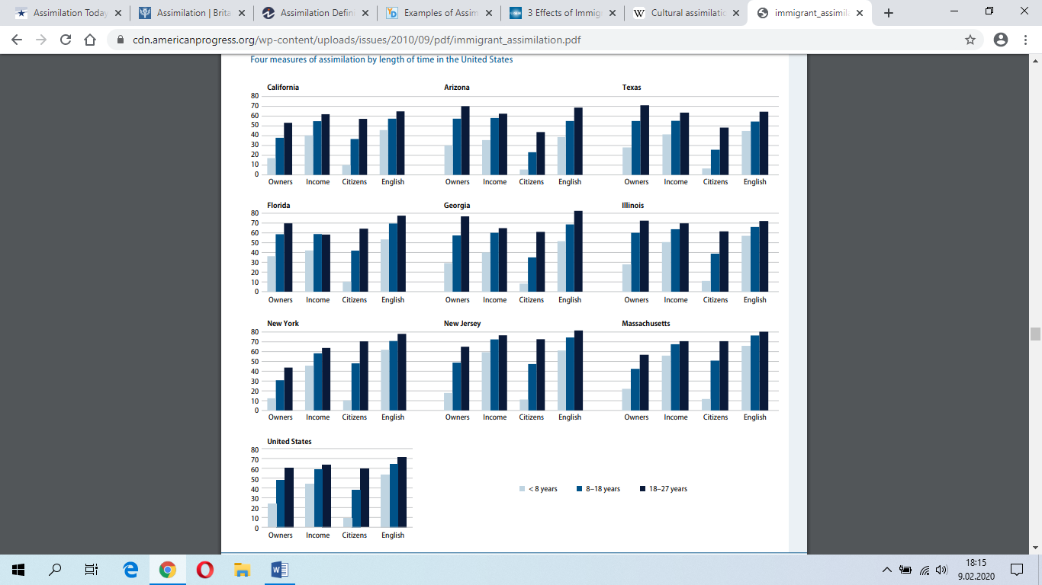

**Bibliography and further Readings:**

<https://www.britannica.com/topic/assimilation-society>

<https://www.americanprogress.org/issues/immigration/reports/2010/09/01/8385/assimilation-today/>

<https://www.investopedia.com/terms/a/assimilation.asp>

<https://examples.yourdictionary.com/examples-of-assimilation.html>

<https://www.nap.edu/read/4942/chapter/5>

<https://en.wikipedia.org/wiki/Cultural_assimilation#Indigenous_assimilation>

<https://cdn.americanprogress.org/wp-content/uploads/issues/2010/09/pdf/immigrant_assimilation.pdf>